**CN Quiz1**

Name: Erwin Wu

Student ID: 17M38147

One is a social network (users and their friendship) and the other is the Internet (routers and their connections). Compare them from the following viewpoints and answer which is which.

– degree distribution

– distance between two nodes

– the number of cycles (loops)

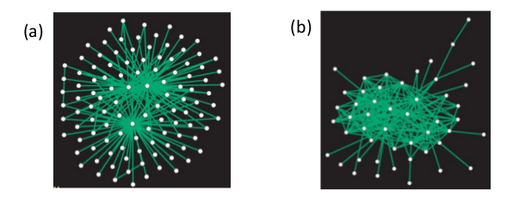a) This is a Internet network, It’s obvious that the degree distribution of edges is concentrate while the distance between two nodes is short. Plenty of nodes’ edges focus on some central nodes, but there are less number of cycles in the network. So it’s just like the Internet, every vertice stands for a computer and the edges are for routes or network connections. The nodes connect to central server so it becomes a kind of star-shape network.

b) This is a Social network, the degree distribution of edges is sparse and the mean of distance between two nodes is larger than image (a), what’s more, there are quite a few cycles in it. So we can say the node stands for person and the edges mean the relation between them. It’s possible for human beings to have long distance relationship with others while the relationships might also loop so it’s a kind of cycled network.

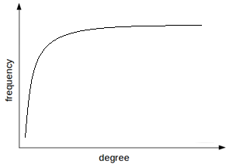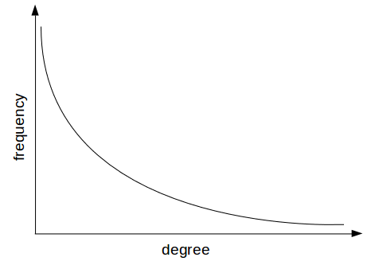The frequency-degree graph of the two network is showing as follows:

1. Internet (b) Social network